Part A – Amazon S3

1. Create S3 Bucket & Host Static Website (10m)

Create a new bucket, enable static website hosting, upload index.html and error.html, and make it public.

And

2. Enable Versioning   (5m)

Turn on versioning and upload two versions of the same file.

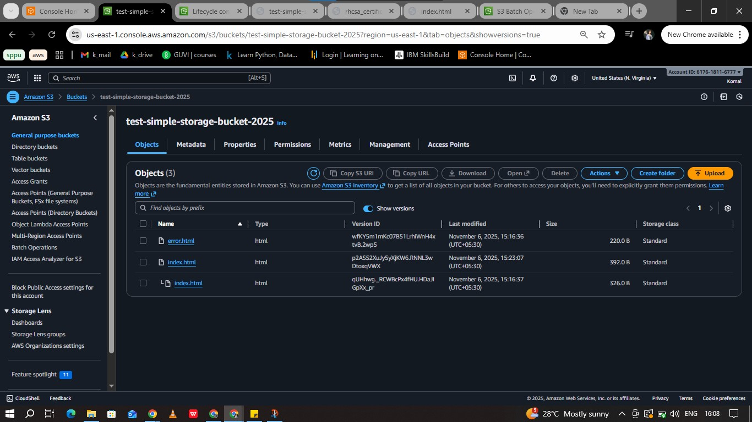

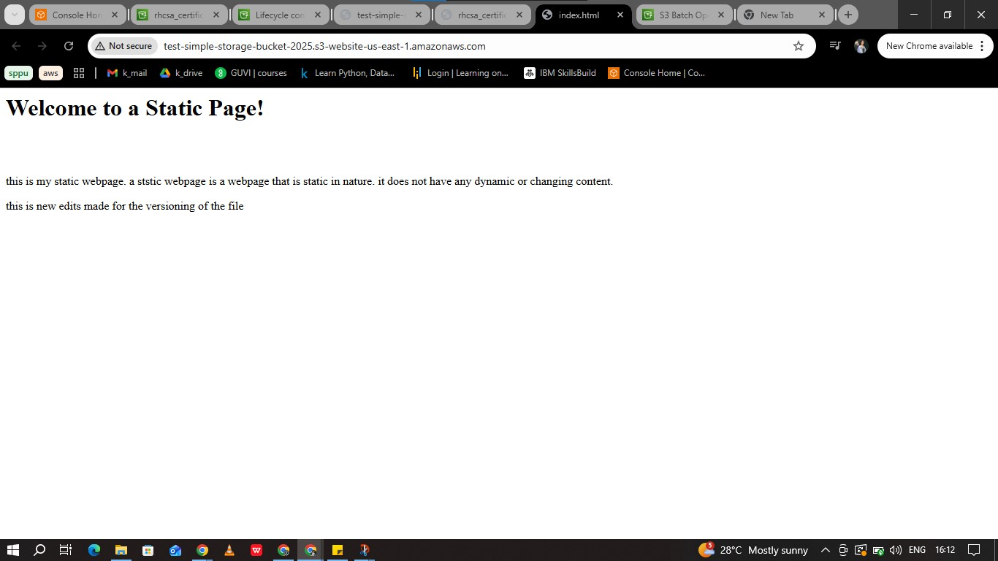

3. Cross-Region Replication  (10m)

Create another bucket in a different region and enable replication.

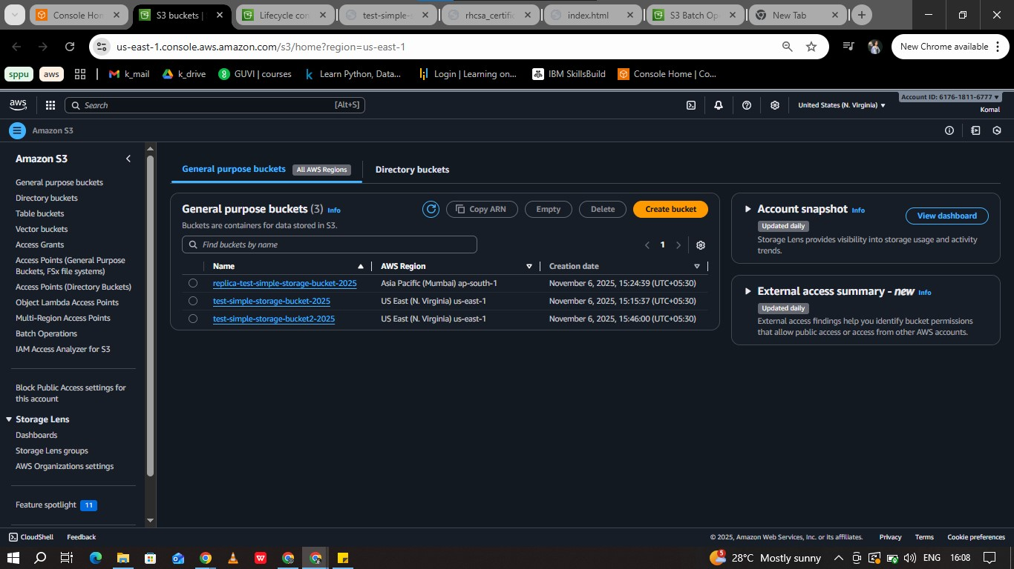

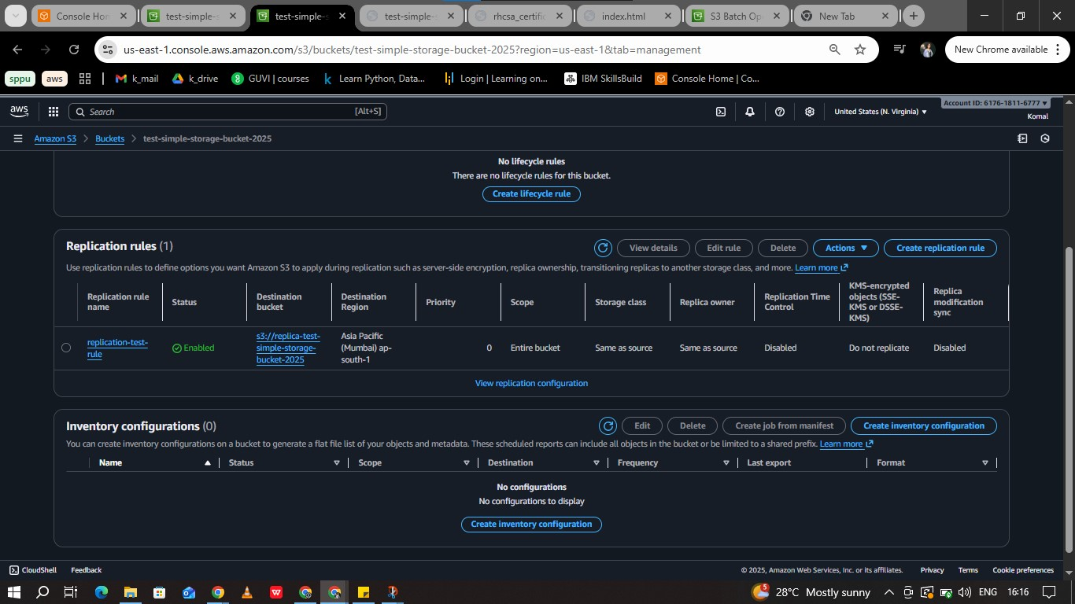

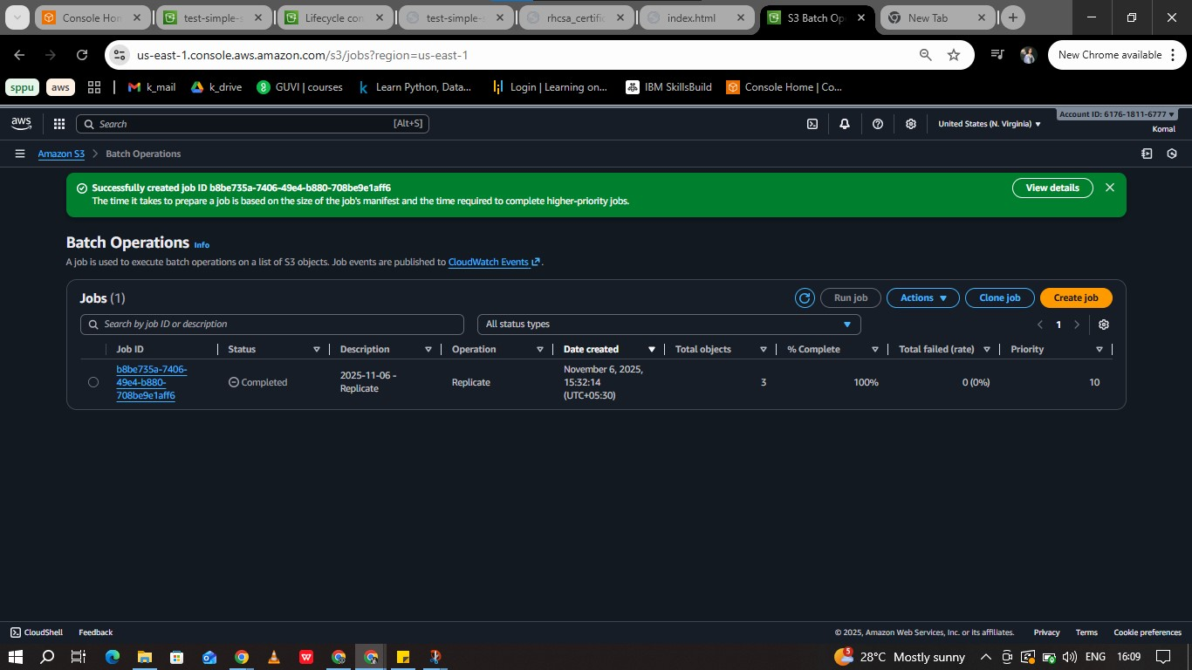

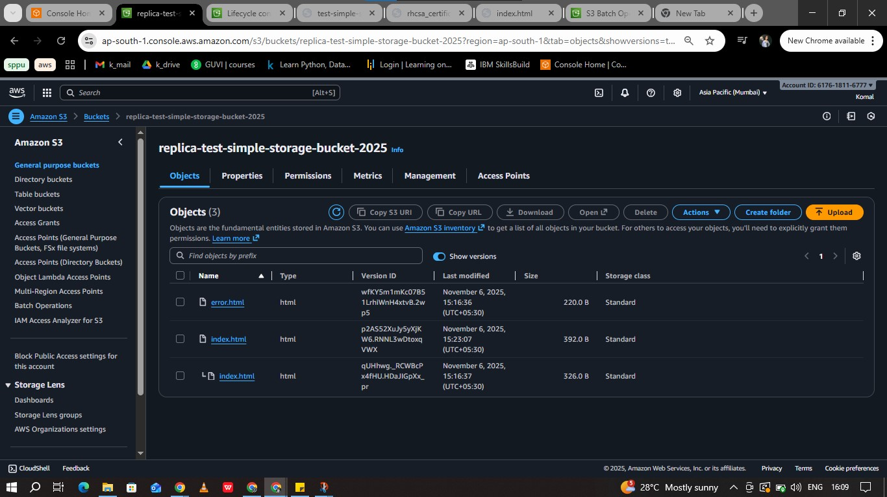

4. Data Encryption (5m)

Upload a file with SSE-S3 and SSE-KMS encryption and show it’s encrypted.

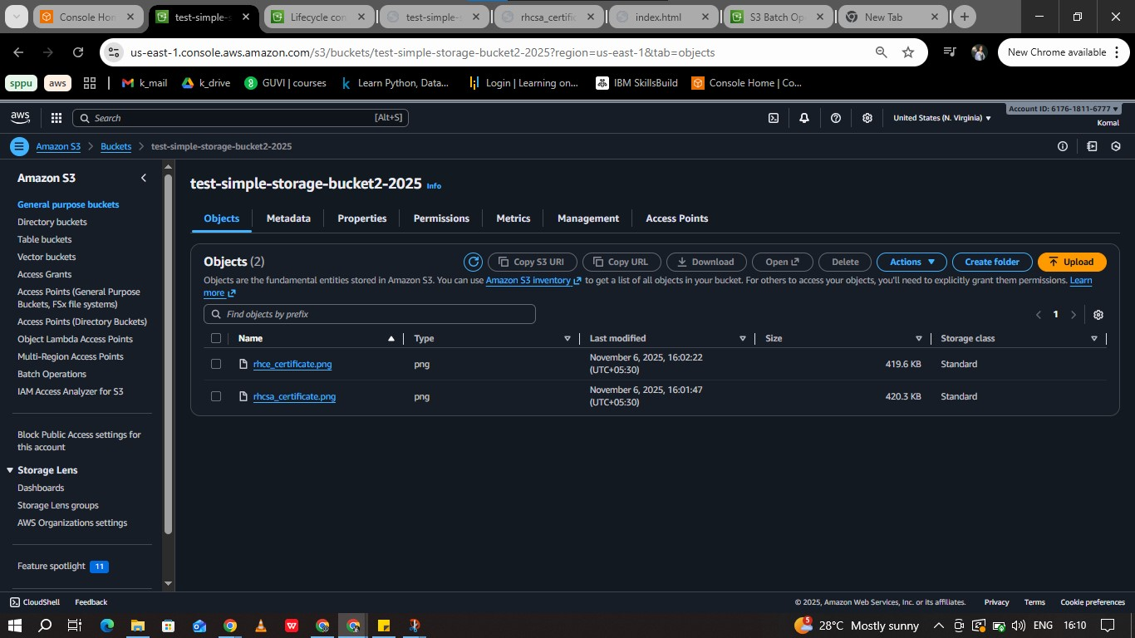

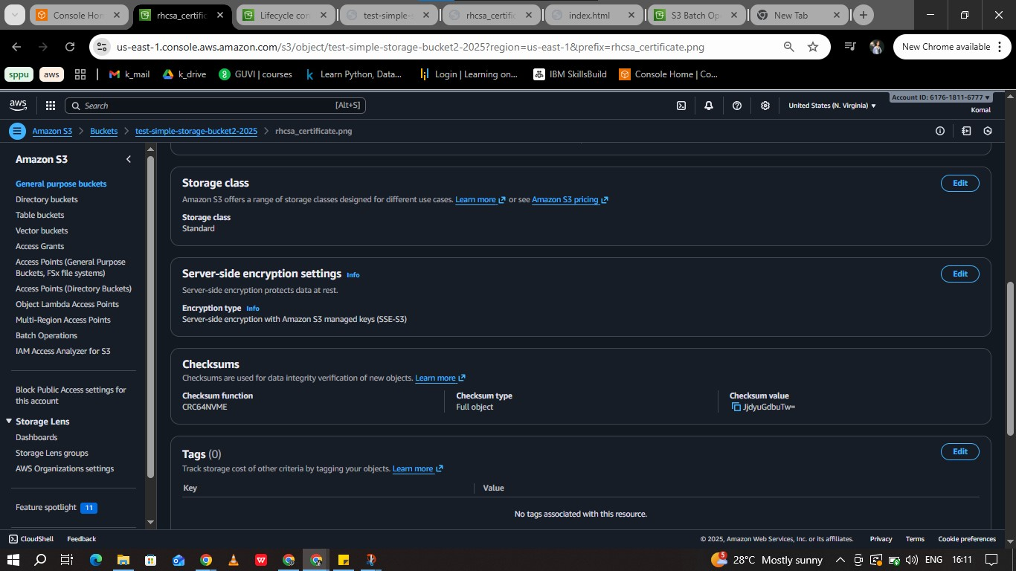

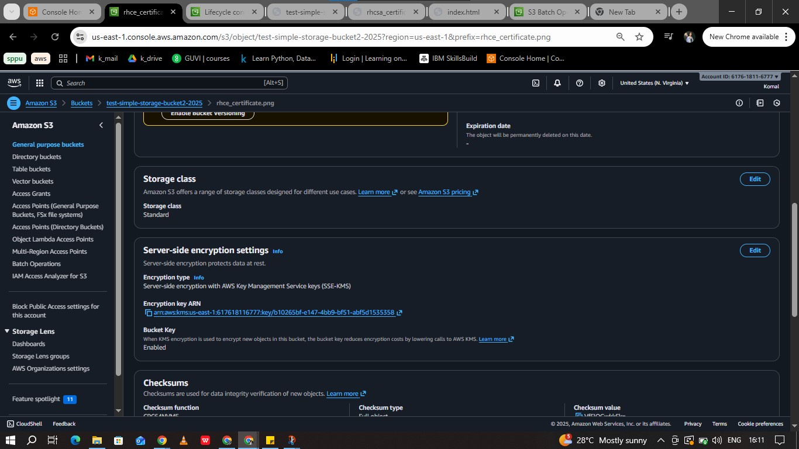

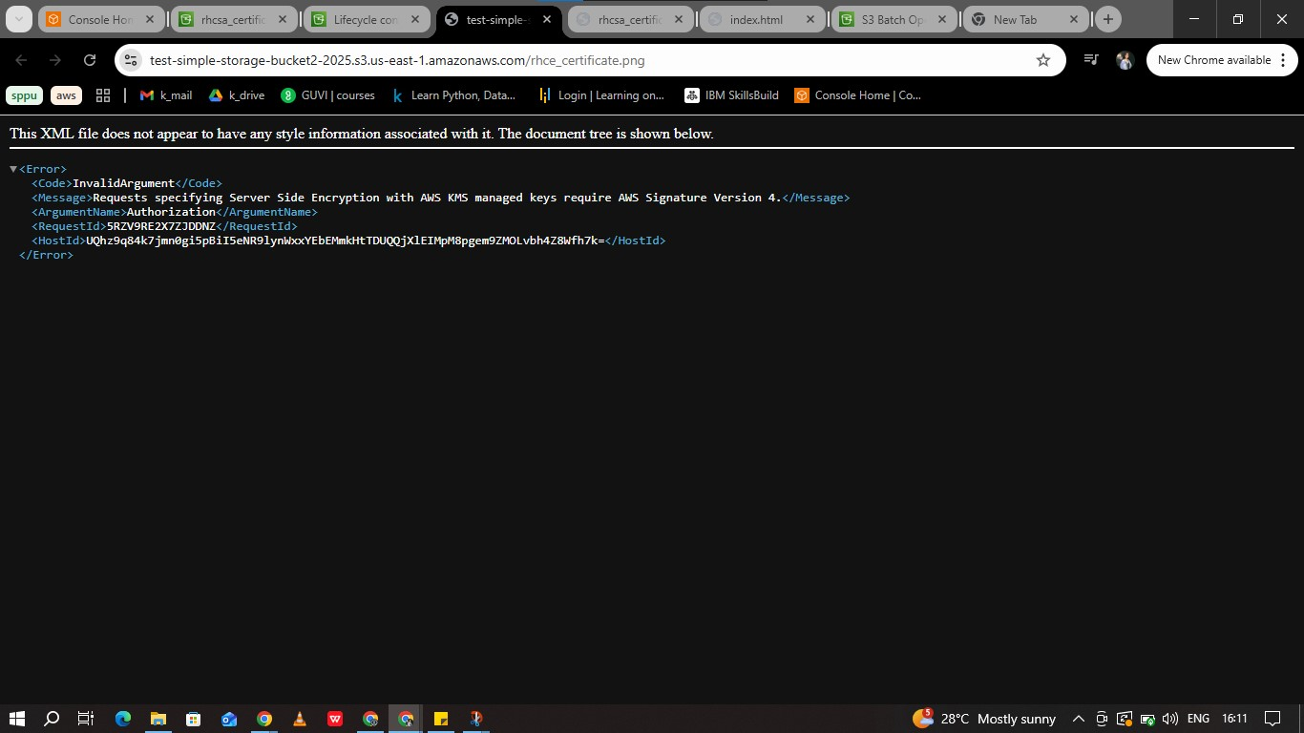

5. Bucket Policy  (5)

Add a policy to allow public read and deny insecure (non-HTTPS) requests.

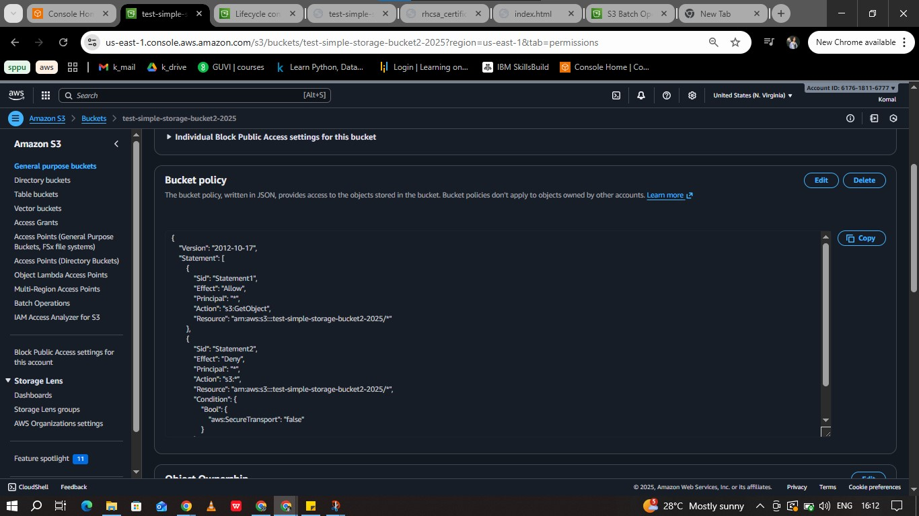

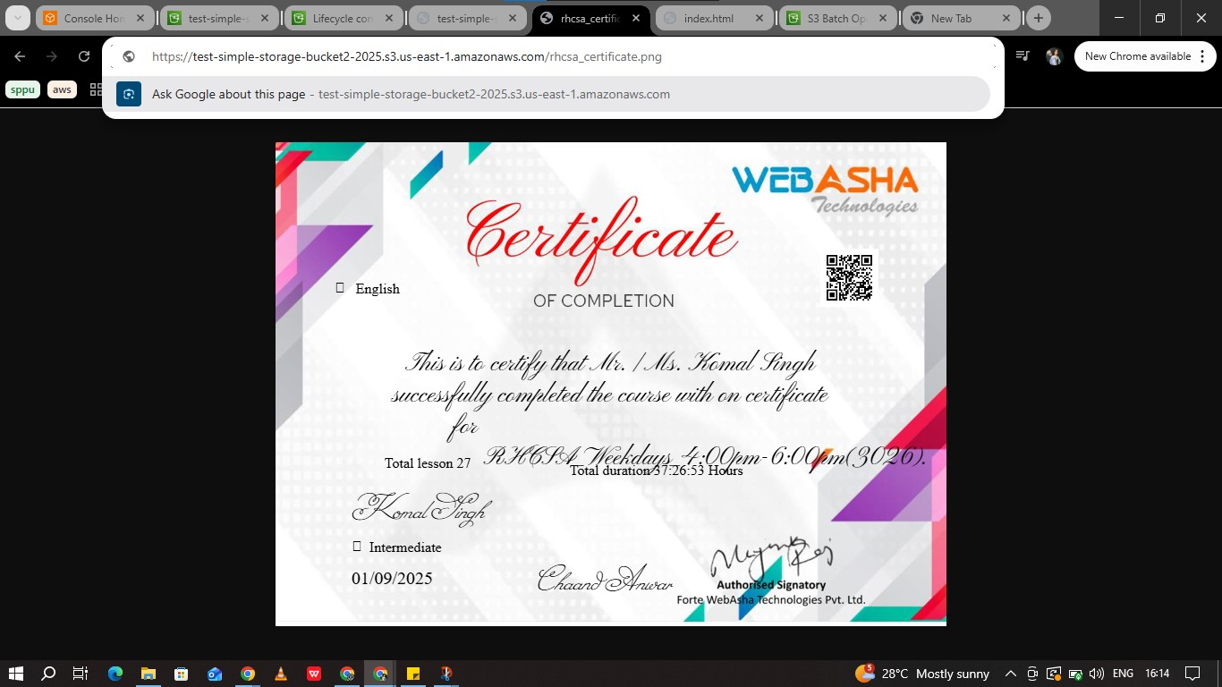

6. Storage Classes & Lifecycle Rule  (5)

Upload files in different storage classes and create a lifecycle rule to move data to Glacier

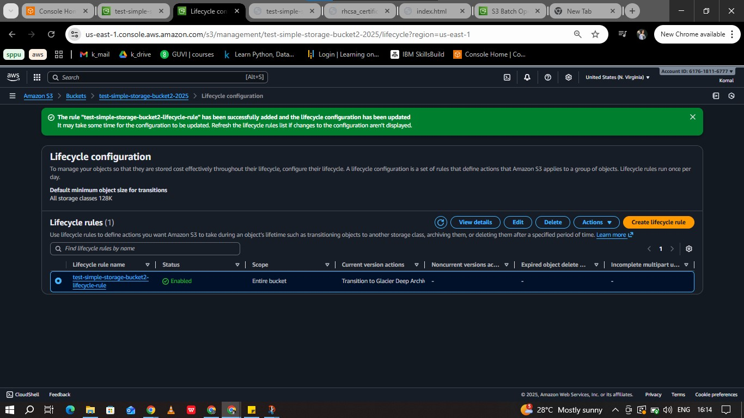

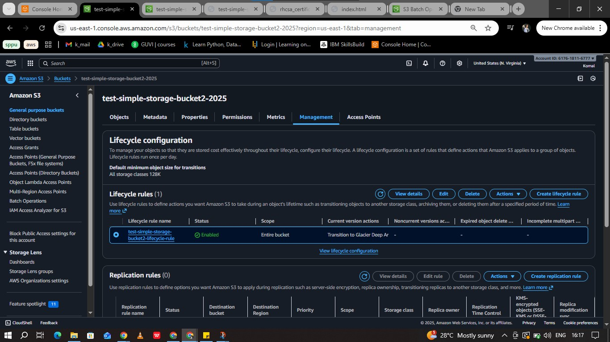

7. Logging / Monitoring  (5m)

Enable access logging and CloudWatch metrics for S3.

8. Storage Gateway / Snow Family (Explain only)  (5m)

Short explanation of hybrid storage and Snow Family use cases.

Answer:

Storage Gateway – Hybrid Storage

* It allows us to connect our on-premises applications with aws cloud storage.
* We can use storage gateway when we want to access our on-premises applications and also take the advantages of the cloud storage to store our data.
* We can use the cloud storage

1. to store the back-ups
2. archive data that are not needed frequently
3. encrypt data that shall not be accessed by everybody

* With the use of AWS hybrid cloud storage, the data can be cached at low latency, total cost can be optimised and more importantly the data can be managed efficiently.

Snow Family

* Amazon Snow Family is used for large-scale data transfer and edge computing.
* With the help of Snow Family we can perform compute workloads at locations with no or less network connectivity.
* Snow Family is also used when one needs to migrate or transfer huge amount of data at a particular location, providing data security.
* Devices like Snowball, Snowball Edge, and Snowmobile are used to migrate data.

---------------------------------------------------------------------------------------------------------------------------------------------------------------

Part B – Amazon VPC

1. Create VPC (5m)

Create a custom VPC with CIDR [10.0.0.0/16](http://10.0.0.0/16).

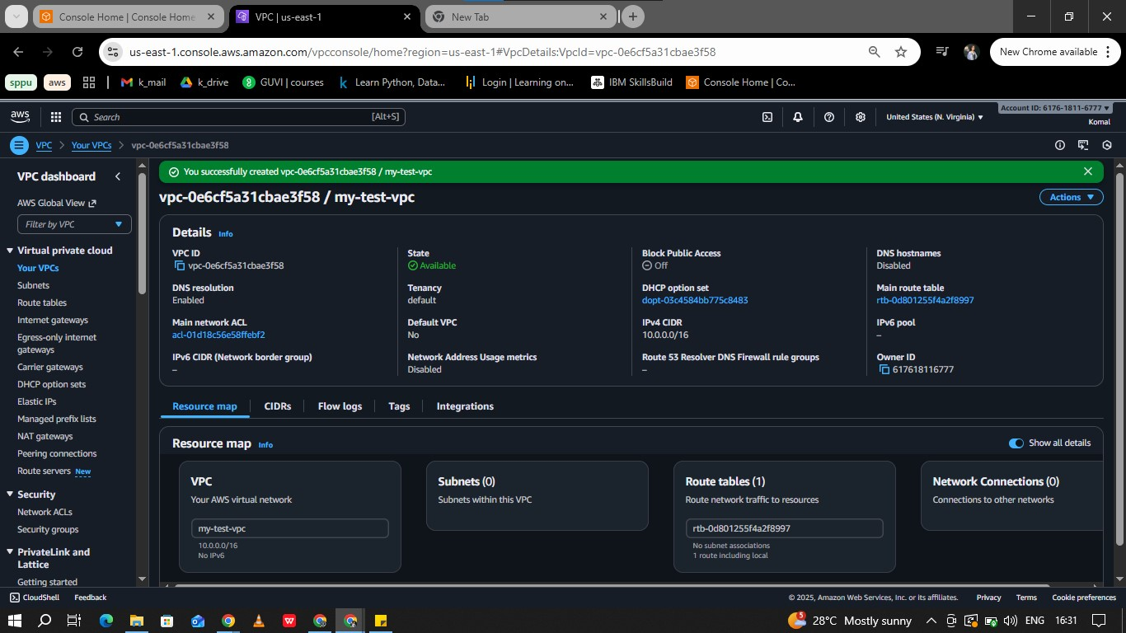

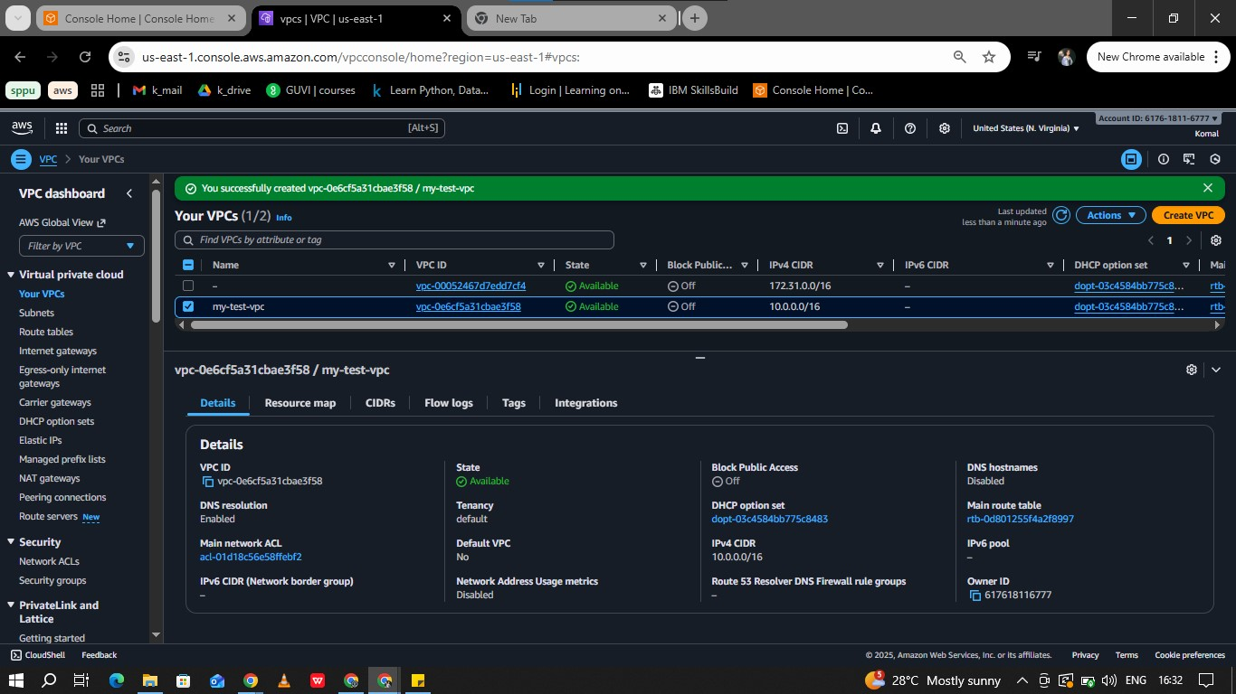

2. Create Subnets  (5m)

Add one public and one private subnet.

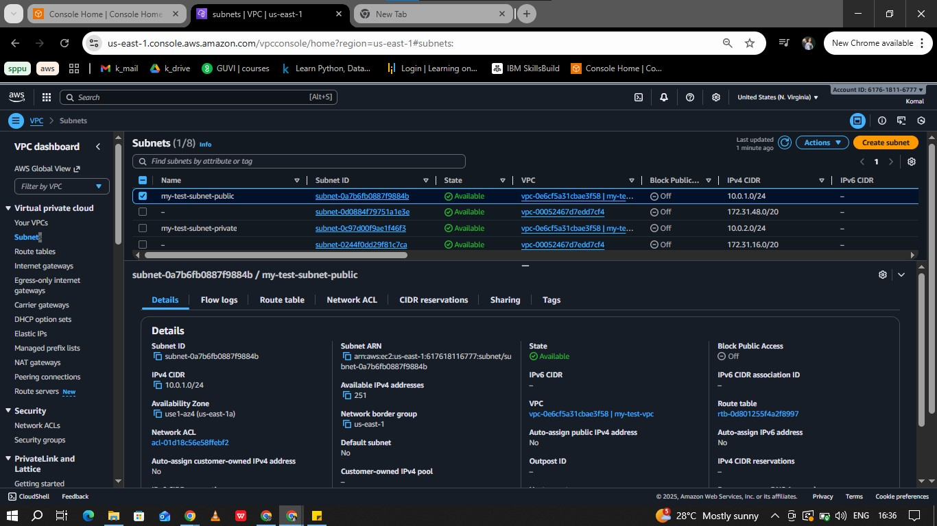

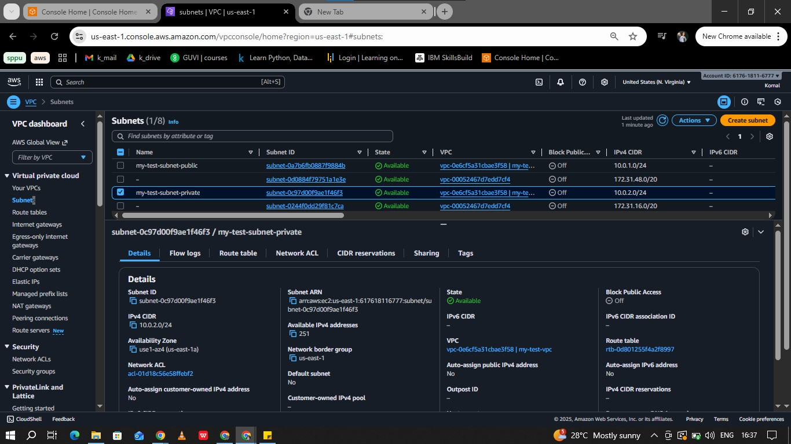

3. Internet Gateway (10m)

Create and attach IGW; route public subnet to the internet.

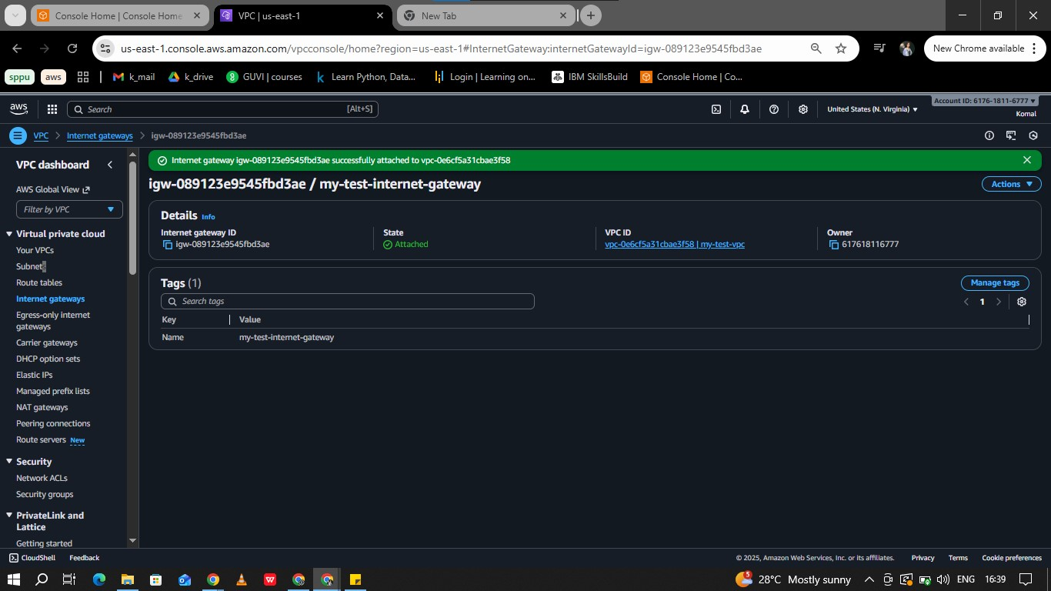

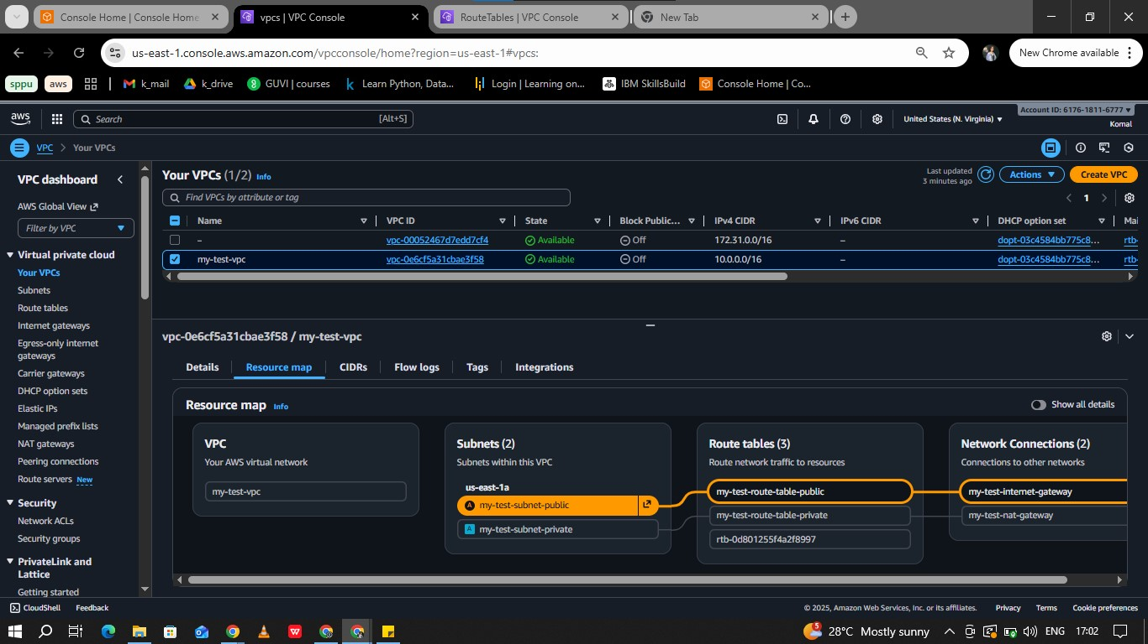

4. NAT Gateway  (5m)

|  |
| --- |
|  |

|  |
| --- |
| Create a NAT Gateway for the private subnet’s internet access. |
| C:\Users\DELL\Documents\KS\aws\vpc\9.jpg |
| C:\Users\DELL\Documents\KS\aws\vpc\13.jpg |
|  |

5. Launch EC2 Instances  (10m)

Launch one EC2 in each subnet (Web + DB)

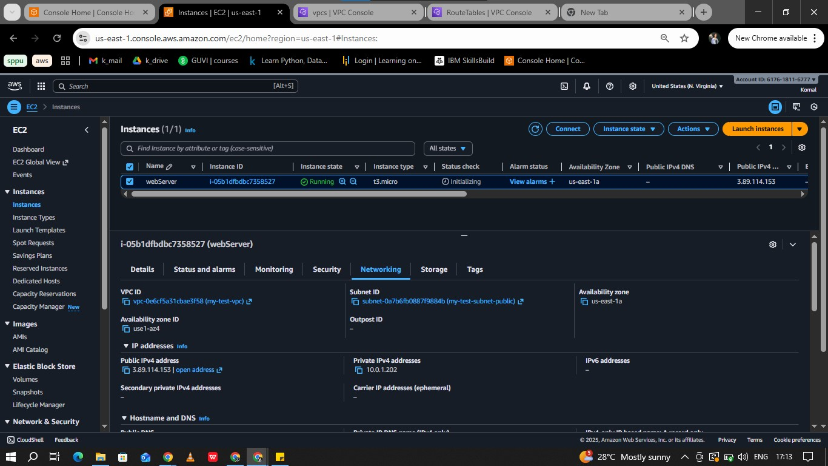

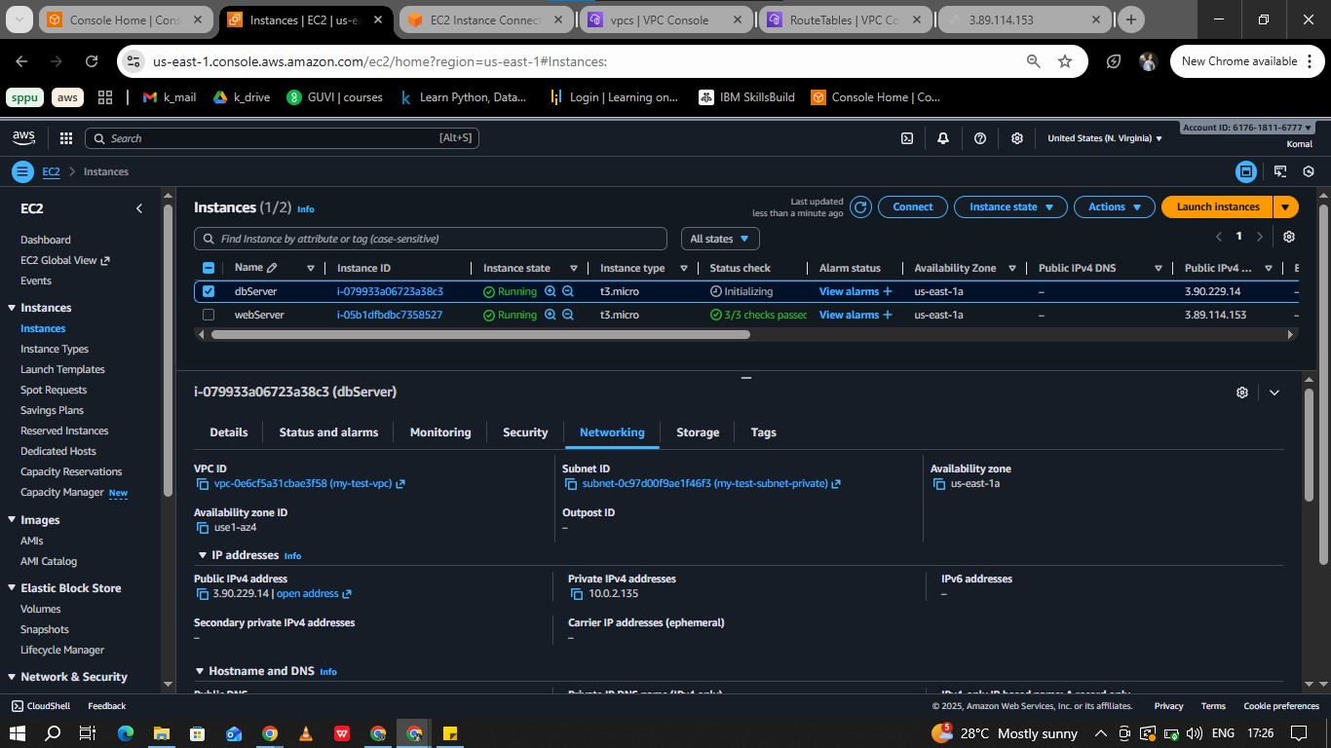

6. Security Groups (10m)

|  |
| --- |
|  |

|  |
| --- |
| Web SG → allow HTTP, HTTPS, SSH; DB SG → allow MySQL from web server only |
| C:\Users\DELL\Documents\KS\aws\vpc\14.jpg  C:\Users\DELL\Documents\KS\aws\vpc\17.jpg |
|  |

7. Verification  (5m)

Show that the public EC2 can access the internet, and the private EC2 can access the internet via NAT

